**Real-Time Shadow Pricing Business Intelligence System: Empowering businesses with real-time insights**

**Abstract**

The Real-Time Shadow Pricing Business Intelligence (BI) System is an innovative AI-driven pricing optimization tool that enables businesses to dynamically adjust pricing strategies based on real-time market conditions, competitor pricing, demand fluctuations, and customer behavior. Unlike traditional dynamic pricing models limited to specific industries like airlines and ride-sharing, this system caters to SaaS, e-commerce, retail, B2B services, and subscription-based businesses by leveragingmachine learning, predictive analytics, and NLP-driven competitive intelligence. A key feature is its Shadow Pricing Simulation Engine, which allows businesses to test and forecast pricing changes before implementation, reducing risk and revenue volatility. The system continuously monitors external economic factors, supply chain disruptions, and customer sentiment to recommend optimal, data-driven pricing adjustmentsin real time, ensuring businesses remain competitive while maximizing profitability. This BI model is a novel approach that transcends existing pricing tools by offering automated competitive response strategies, adaptive price segmentation, and real-time economic insights, making it a first-of-its-kind solution for businesses seeking agile, intelligence-driven pricing optimization.

**Introduction**

In today's highly competitive business landscape, pricing strategies play a critical role in determining a company's success. Traditional pricing models often rely on historical data and periodic adjustments, which can result in missed revenue opportunities and suboptimal profit margins. Businesses operating in dynamic markets—such as **SaaS, e-commerce, retail, and B2B services**—require more agile pricing mechanisms that respond to real-time changes in **demand, competition, and external economic factors**. However, most existing pricing models either lack real-time responsiveness or are confined to specific industries, leaving a gap for a more adaptive and intelligent approach.

The **Real-Time Shadow Pricing Business Intelligence (BI) System** introduces a novel, AI-powered solution that continuously monitors **market conditions, competitor pricing, supply chain disruptions, and customer behavior** to provide real-time pricing recommendations. Unlike traditional dynamic pricing tools that apply pre-set rules, this system leverages **machine learning, predictive analytics, and NLP-based competitive intelligence** to analyze price fluctuations and suggest the most effective pricing strategies. A unique feature of this system is the **Shadow Pricing Simulation Engine**, which allows businesses to test potential price changes in a risk-free virtual environment before implementation, ensuring optimized pricing decisions that maximize both revenue and customer retention.

By integrating real-time analytics with **automated competitive response strategies and adaptive price segmentation**, this BI solution offers businesses an **unparalleled level of pricing intelligence**. It enables companies to anticipate competitor moves, react to external economic shifts, and optimize pricing dynamically without sacrificing long-term customer trust. This approach represents a **first-of-its-kind innovation in business intelligence**, providing organizations with a smarter, data-driven methodology for pricing optimization that has yet to be fully explored across diverse industries.

### ****Review of Literature on Business Intelligence****

1. **Evolution of Business Intelligence**
   * **Watson & Wixom (2007)** highlighted that Business Intelligence (BI) evolved from Decision Support Systems (DSS) and has become a key enabler of data-driven decision-making. They emphasized that BI integrates **data warehousing, analytics, and reporting tools** to enhance business performance.
2. **Critical Success Factors for BI Implementation**
   * **Yeoh & Koronios (2010)** conducted a study identifying **top management support, data quality, user involvement, and clear vision** as the key factors influencing BI system success. Their research indicated that businesses with strong leadership commitment and a well-defined BI strategy achieve better outcomes.
3. **Impact of BI on Organizational Performance**
   * **Elbashir et al. (2008)** found that BI adoption significantly improves **financial and operational performance**. Their study demonstrated that companies leveraging BI for **real-time insights and predictive analytics** gained a competitive edge in decision-making.
4. **BI and Competitive Advantage**
   * **Davenport & Harris (2017)** explored how **big data and BI** contribute to competitive advantage. They found that organizations using **AI-driven BI analytics** for **customer segmentation, risk assessment, and process optimization** outperform their competitors.
5. **Strategic Alignment of BI**
   * **Popovič et al. (2012)** argued that BI systems must be **aligned with business objectives** to maximize value. Their research showed that firms integrating BI insights into their strategic planning achieve **higher efficiency and better market responsiveness**.

**Existing Systems**

One of the most widely used **existing BI systems** is **Tableau**. It is a powerful data visualization and analytics tool that helps organizations understand their data through interactive dashboards, reports, and visualizations.

### ****Overview of Tableau****

* **Developed by**: Tableau Software (acquired by Salesforce in 2019)
* **Core Features**:
  1. **Data Integration**: Tableau can connect to a wide variety of data sources, such as **databases (SQL, NoSQL), cloud services (Google Analytics, Salesforce), Excel spreadsheets**, and more.
  2. **Data Visualization**: Users can create intuitive and interactive visualizations, including bar charts, line graphs, heat maps, and geospatial visualizations, to better understand data trends.
  3. **Real-Time Analytics**: Tableau allows **real-time data analysis**, enabling businesses to monitor performance continuously and make timely decisions.
  4. **Drag-and-Drop Interface**: Its user-friendly interface allows even non-technical users to **drag and drop** data fields to create visual reports without needing to write complex code.
  5. **Advanced Analytics**: Features like **forecasting, trend analysis, and statistical calculations** make it a powerful tool for in-depth data analysis.
  6. **Collaboration and Sharing**: Tableau supports collaboration across teams with features that allow users to share dashboards and reports easily, fostering data-driven decision-making at all levels of an organization.

### ****Real-World Use Case****

* **Honeywell**: Honeywell, a global technology and manufacturing leader, uses Tableau for visualizing and analyzing data from across its supply chain. With **real-time data analysis**, Honeywell can identify potential disruptions, optimize inventory management, and improve operational efficiency.

**Proposed System**:

The **Real-Time Shadow Pricing Business Intelligence (BI) System** is a cutting-edge solution designed to optimize pricing strategies by integrating **predictive analytics, competitive intelligence, and real-time market data**. The goal of this system is to provide businesses with a dynamic and responsive pricing model that can adjust in real-time to changing market conditions. By simulating the impact of various pricing strategies in a virtual environment before actual implementation, the system minimizes the risks associated with pricing decisions and maximizes profitability. It leverages **AI-powered machine learning** and **competitive data analysis** to continuously refine pricing decisions, ensuring that businesses can stay competitive while optimizing revenue.

The core functionality of the system centers on its **Shadow Pricing Simulation Engine**, which allows businesses to test different pricing scenarios in a safe, virtual environment. By feeding real-time market data, competitor pricing, and demand forecasts into the system, the engine simulates the effects of pricing adjustments on key business metrics such as **sales volume**, **profit margins**, and **customer acquisition**. This capability helps businesses assess the effectiveness of potential pricing strategies without the need to implement them immediately, thus reducing the risk of adverse outcomes. The system's ability to simulate real-world pricing decisions makes it particularly valuable for industries with volatile market conditions or price-sensitive customers.

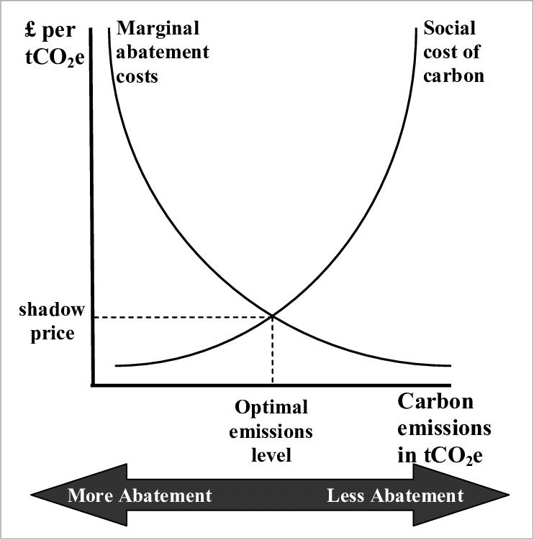

Here’s how the **Real-Time Shadow Pricing BI System** works:

1. **Data Collection**:
   * Gathers data from internal systems (sales, customer profiles, inventory) and external sources (competitor pricing, market trends, social media sentiment).
2. **Data Integration**:
   * Integrates and stores all collected data in a centralized data warehouse for efficient processing.
3. **Shadow Pricing Simulation Engine**:
   * Simulates multiple pricing scenarios, adjusting variables like product prices, demand forecasts, and competitor actions.
   * Analyzes the impact of these scenarios on key metrics (sales, profits, customer acquisition).
4. **Risk Assessment**:
   * Assesses risks associated with each scenario (e.g., price wars, customer churn) to minimize adverse outcomes.
5. **Predictive Analytics & Machine Learning**:
   * Uses machine learning algorithms to predict demand fluctuations and customer behavior.
   * Continuously refines pricing strategies based on past data and market conditions.
6. **Real-Time Alerts**:
   * Provides instant notifications about competitor price changes or market shifts, allowing businesses to adjust pricing quickly.
7. **Dynamic Pricing Adjustments**:

Based on the simulation results, predictive models, and real-time data, the system dynamically adjusts prices to optimize profitability while maintaining competitiveness.



Finally, the system is designed to seamlessly integrate with existing business infrastructures, such as **CRM systems, ERP tools, and supply chain management platforms**. This integration ensures that pricing decisions are not made in isolation but are aligned with broader business objectives, such as inventory management and sales goals. By incorporating data from across the organization, the system provides a holistic view of the business landscape, enabling decision-makers to make more informed pricing decisions that support long-term strategic goals. The flexibility of the system allows it to scale across different industries, whether in **e-commerce**, **SaaS**, **retail**, or **B2B services**, offering a tailored solution for each business model.

**Results and Conclusion:**

In conclusion, the **Real-Time Shadow Pricing Business Intelligence System** offers a comprehensive and innovative approach to pricing optimization. By combining real-time data analysis, AI-driven predictions, and simulation-based testing, this system empowers businesses to make smarter, data-driven pricing decisions. It minimizes the risks associated with pricing strategies, maximizes profitability, and ensures that businesses stay agile in a competitive marketplace. The system's adaptability, predictive power, and integration capabilities make it an invaluable tool for modern businesses seeking to optimize their pricing strategies and stay ahead of the competition.

**References**

*[1]Friedman T and Strange K H: ‘Architecture: The Foundation of Business Intelligence’, Gartner (April, 2004).*

*[2] Dresner H J, Hostmann B, Tiedrich A H and Buytendijk F: ‘Magic Quadrants for Business Intelligence, 1H04’, Research Report, Gartner (April 2004).*

*[3] Nauck D, Spott M and Azvine B: ‘SPIDA — a novel data analysis tool’, BT Technol J, 21, No 4, pp 104—112 (October 2003).*

*[4] Nauck D, Klawonn F and Kruse R: ‘Foundations of Neuro-Fuzzy Systems’, Wiley, Chichester (1997).*

*[5] Azvine B, Nauck D and Ho C: ‘Intelligent business analytics — a tool to build decision-support systems for eBusinesses’, BT Technol J, 21, No 4, pp 65—71 (October 2003).*

*[6] Azvine B, Ho C, Kay S, Nauck D and Spott M: ‘Estimating travel times of field engineers’, BT Technol J, 21, No 4, pp 33—38 (October 2003).*

*[7] Cui Z, Shepherdson J W and Li Y: ‘An ontology-based approach to eCatalogue management’, BT Technol J, 21, No 4, pp 76—83 (October 2003).*

*[8] Cui Z, Shepherdson J W, and Li Y: ‘Staying ‘on message’ — mapping from A to B’, BT Technol J, 21, No 4, pp 123—129 (October 2003).*

*[9] ‘Microsoft: Business intelligence for the masses’, Computer Weekly (November 2002) — http://www.computerweekly.com/Article117748.htm*